SIMATS ENGINEERING

ASSESSMENT TOOL 1
COURSE CODE: CSA0713 COURSE NAME: COMPUTER NETWORKS

COURSE OUTCOME COVERED
CO2: Configure IP addressing schemes, subnetting, and basic routing techniques
using simulation tool, for efficient network design and topology. (BL3)
Assessment Tool Weightage: 40%

Annexure A

ANALYTICAL PROBLEM SOLVING

Code of Conduct:
Dakshin S (192511431)
I ____________________ (Name / Reg No) certify that this submission is my original work
and that I have adhered to the guidelines specified for this assessment.
I understand that any violation of academic integrity rules will result in disciplinary action.

Signature of the student: Dakshin S
Annexure A

ANALYTICAL PROBLEM SOLVING
- Suppose we want to transmit the message 11100011 and protect it from errors using the CRC polynomial X3+1.
i.) Use polynomial long division to determine the message that should be transmitted.
ii) Suppose the leftmost bit of the message is inverted due to noise on the transmission link. What is the result of the receiver's CRC calculation? How does the receiver know that an error has occurred?
SOLUTION:
Given
Message = 11100011, Generator polynomial G(x) = x³ + 1 → binary 1001 (4 bits, degree 3)

Part (i): Find the transmitted codeword
Step 1 — Append r = 3 zero bits (degree of G(x) = 3) to the message:
11100011 000 → 11100011000
Step 2 — Divide by 1001 using modulo-2 (XOR) division:
1 1 0 0 1 0 1 0 ← quotient (not needed)
-----------------------
1001 ) 1 1 1 0 0 0 1 1 0 0 0
1 0 0 1
--------
0 1 1 1 0
1 0 0 1
--------
0 1 1 1 1
1 0 0 1
--------
0 1 1 0 1
1 0 0 1
--------
0 1 0 0 0
1 0 0 1
--------
0 0 0 1 0
0 0 0 0
--------
0 0 1 0 0
Remainder (CRC) = 100
Transmitted codeword T = Message + CRC = 11100011 + 100 = 11100011100
(Verification: x¹⁰+x⁹+x⁸+x⁴+x³ divided by x³+1 leaves remainder x² =100)

Part (ii): Leftmost bit inverted — what does the receiver see?
- Original leftmost bit (position 1) = 1 → inverted to 0
- Received codeword: 01100011100
The receiver divides the received bits by the same generator 1001.
Since the error is a single-bit flip at the leftmost position, the error polynomial is E(x) = x¹⁰. Because x³ ≡ 1 (mod x³+1), we get x¹⁰ = (x³)³·x ≡ x, so:
Remainder = x → 010 (non-zero)
Conclusion: Because a valid, error-free codeword always divides evenly (remainder = 000), a non-zero remainder (010) tells the receiver an error has occurred, and the frame is discarded / retransmission is requested. (A single generator with more than one term, like x³+1, is guaranteed to detect any single-bit error.)

- a) A network with bandwidth of 10 Mbps can pass only an average of 12,000 frames per minute with each frame carrying an average of 10,000 bits. What is the throughput of this network?
b) A network has a bandwidth of 3000 Hz (300 to 3300 Hz) assigned for data communications. The signal- to-noise ratio is 3162. Find the channel capacity
SOLUTION:
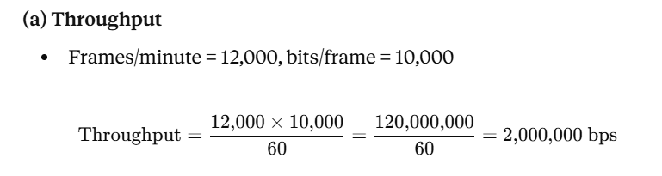
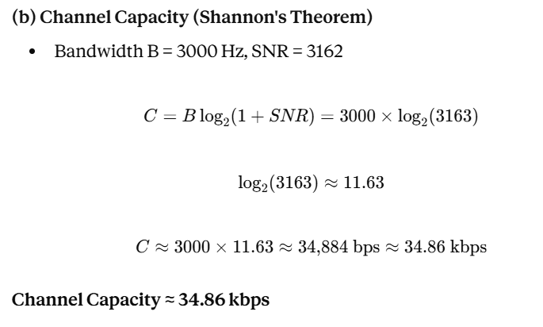
- A multispecialty hospital uses wireless patient-monitoring devices to continuously transmit patients' heart rate and blood pressure readings to a central monitoring station. Since the data is transmitted over a wireless channel, electromagnetic interference occasionally changes one bit during transmission. To ensure that doctors receive accurate patient information without waiting for retransmission, the hospital implements the Hamming (12,8) error-correcting code.
SOLUTION:
Why Hamming(12,8)? For 8 data bits (m = 8), the number of parity bits r must satisfy:
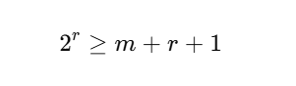
With r = 4: 2⁴ = 16 ≥ 8+4+1 = 13 → Total codeword length n = m + r = 12 bits, hence "Hamming(12,8)."
Bit layout (positions 1–12): Parity bits go in power-of-2 positions (1, 2, 4, 8); data bits fill the rest.
Position | 1 | 2 | 3 | 4 | 5 | 6 | 7 | 8 | 9 | 10 | 11 | 12
Bit type | P1 | P2 | D1 | P4 | D2 | D3 | D4 | P8 | D5 | D6 | D7 | D8
Each parity bit checks a specific set of positions (based on binary place value):
- P1 → positions 1,3,5,7,9,11
- P2 → positions 2,3,6,7,10,11
- P4 → positions 4,5,6,7,12
- P8 → positions 8,9,10,11,12

Worked example (illustrative patient-data byte = 10011010, i.e., D1..D8 = 1,0,0,1,1,0,1,0)
Computing each parity (even parity):
Parity | Checks | Data values | Sum | Parity bit
P1 | 3,5,7,9,11 | 1,0,1,1,1 | 4 (even) | 0
P2 | 3,6,7,10,11 | 1,0,1,0,1 | 3 (odd) | 1
P4 | 5,6,7,12 | 0,0,1,0 | 1 (odd) | 1
P8 | 9,10,11,12 | 1,0,1,0 | 2 (even) | 0
Transmitted codeword: 0 1 1 1 0 0 1 0 1 0 1 0

Error correction in action
Suppose interference flips bit 7 (0→... i.e., 1 becomes 0). Received: 0 1 1 1 0 0 0 0 1 0 1 0
The receiver recomputes each parity check (syndrome bits C1, C2, C4, C8):

Check | Positions | Values | Sum | Result
C1 | 1,3,5,7,9,11 | 0,1,0,0,1,1 | odd | 1
C2 | 2,3,6,7,10,11 | 1,1,0,0,0,1 | odd | 1
C4 | 4,5,6,7,12 | 1,0,0,0,0 | odd | 1
C8 | 8,9,10,11,12 | 0,1,0,1,0 | even | 0
Syndrome = C8 C4 C2 C1 = 0111 = decimal 7 → the error is at position 7.
The receiver flips bit 7 back (0→1), fully recovering the correct patient data without needing retransmission — exactly why the hospital chose Hamming(12,8): it self-corrects single-bit errors introduced by EM interference in real time, which is critical for continuous vital-sign monitoring.
- a) A company uses the IP address 172.16.10.0/24 and has implemented subnetting using a
/27 subnet mask for its internal departments. Using the given subnet mask, apply subnetting techniques to calculate the total number of subnets created and the number of usable hosts per subnet. Determine the subnet to which the IP address 172.16.10.78 belongs. Identify the network address and broadcast address for that subnet. Also, determine whether the IP address 172.16.10.95 falls within the same subnet range based on the given configuration.

b) A network uses the Internet Protocol version 6 address 2001:0db8:0000:0000:0000:ff00:0042:8329. Apply IPv6 addressing rules to compress the given address into its shortest form and then expand the compressed address back to its full
notation.Using a prefix length of /64,determine the network prefix of the given address.Also, calculate the total number of possible host addresses available within this network based on the given prefix length.
SOLUTION:

a) Subnetting: 172.16.10.0/24 → /27
- Borrowed bits = 27 − 24 = 3 → Number of subnets = 2³ = 8
- Host bits = 32 − 27 = 5 → Total addresses/subnet = 2⁵ = 32 → Usable hosts/subnet = 32 − 2 = 30
- Block size = 256 / 8 = 32
Subnet # | Network Address | Broadcast Address | Usable Range
0 | 172.16.10.0 | 172.16.10.31 | .1–.30
1 | 172.16.10.32 | 172.16.10.63 | .33–.62
2 | 172.16.10.64 | 172.16.10.95 | .65–.94
3 | 172.16.10.96 | 172.16.10.127 | .97–.126
4 | 172.16.10.128 | 172.16.10.159 | .129–.158
5 | 172.16.10.160 | 172.16.10.191 | .161–.190
6 | 172.16.10.192 | 172.16.10.223 | .193–.222
7 | 172.16.10.224 | 172.16.10.255 | .225–.254
172.16.10.78 → falls in Subnet 2 (172.16.10.64/27)
- Network address = 172.16.10.64
- Broadcast address = 172.16.10.95
Is 172.16.10.95 in the same subnet? Yes — it lies within the 172.16.10.64–95 range. However, note it is the broadcast address of that subnet, not an assignable host address.

b) IPv6 Addressing & Compression
Given Address:
2001:0db8:0000:0000:0000:ff00:0042:8329
Compression Rules Applied:
1. Rule 1 (Leading Zeros):* Omit leading zeros in any 16-bit block (0000 \right arrow 0, 0db8 \right arrow db8, 0042 \right arrow 42).

2. Expanding Back to Full Notation
Re-inserting omitted zeros into all 8 nibble groups gives:

3. Network Prefix & Total Host Addresses (/64 Prefix)
Network Prefix:* Take the first 64 bits (the first 4 blocks/hextets) and zero out the host portion:

Total Possible Host Addresses:*
* Host bits remaining = 128 - 64 = 64\text{ bits}
* Total addresses = 2^{64} = \mathbf{18,446,744,073,709,551,616} (over 18.4 quintillion addresses)

- a) A company uses the IP address 172.16.10.0/24 and has implemented subnetting using a
/27 subnet mask for its internal departments. Using the given subnet mask, apply subnetting techniques to calculate the total number of subnets created and the number of usable hosts per subnet. Determine the subnet to which the IP address 172.16.10.78 belongs. Identify the network address and broadcast address for that subnet. Also, determine whether the IP address 172.16.10.95 falls within the same subnet range based on the given configuration.

b) A network uses the Internet Protocol version 6 address 2001:0db8:0000:0000:0000:ff00:0042:8329. Apply IPv6 addressing rules to compress the given address into its shortest form and then expand the compressed address back to its full
notation. Using a prefix length of /64, determine the network prefix of the given address. Also, calculate the total number of possible host addresses available within this network based on the given prefix length.
SOLUTION:

a) Subnetting: 172.16.10.0/24 → /27
- Borrowed bits = 27 − 24 = 3 → Number of subnets = 2³ = 8
- Host bits = 32 − 27 = 5 → Total addresses/subnet = 2⁵ = 32 → Usable hosts/subnet = 32 − 2 = 30
- Block size = 256 / 8 = 32
Subnet # | Network Address | Broadcast Address | Usable Range
0 | 172.16.10.0 | 172.16.10.31 | .1–.30
1 | 172.16.10.32 | 172.16.10.63 | .33–.62
2 | 172.16.10.64 | 172.16.10.95 | .65–.94
3 | 172.16.10.96 | 172.16.10.127 | .97–.126
4 | 172.16.10.128 | 172.16.10.159 | .129–.158
5 | 172.16.10.160 | 172.16.10.191 | .161–.190
6 | 172.16.10.192 | 172.16.10.223 | .193–.222
7 | 172.16.10.224 | 172.16.10.255 | .225–.254
172.16.10.78 → falls in Subnet 2 (172.16.10.64/27)
- Network address = 172.16.10.64
- Broadcast address = 172.16.10.95
Is 172.16.10.95 in the same subnet? Yes — it lies within the 172.16.10.64–95 range. However, note it is the broadcast address of that subnet, not an assignable host address.

b) IPv6 Addressing & Compression
Given Address:
2001:0db8:0000:0000:0000:ff00:0042:8329
Compression Rules Applied:
1. Rule 1 (Leading Zeros):* Omit leading zeros in any 16-bit block (0000 \right arrow 0, 0db8 \right arrow db8, 0042 \right arrow 42).

2. Expanding Back to Full Notation
Re-inserting omitted zeros into all 8 nibble groups gives:

3. Network Prefix & Total Host Addresses (/64 Prefix)
Network Prefix:* Take the first 64 bits (the first 4 blocks/hextets) and zero out the host portion:

Total Possible Host Addresses:*
* Host bits remaining = 128 - 64 = 64\text{ bits}
* Total addresses = 2^{64} = \mathbf{18,446,744,073,709,551,616} (over 18.4 quintillion address

